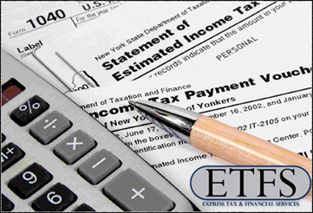
Get Ready for Tax Time!
Tax time can be hectic and stressful! We are committed to helping you during this time by guiding you through this annual process. We’ll start with a list of items frequently missed. Make sure you check it against your list.
√ Employer Reimbursement
√ Child Care Expenses
√ Special Accounts
√ Social Security Benefit
√ Sale of Propert
√ Student Loans
√ College Tuition
GOT IT ALL!!
Here’s a list of items frequently missed. Check it against your list.
- Refinances. We need to see the settlement statement.
- Child Care Expenses. We need full name, address, and telephone and I.D. number of care providers.
- Estimated Tax Payments. Find date and amount for payments. Look near April 15, June 15, and Sept. 15 of 2010, and Jan. 15 of 2011. A Jan. 2010 payment was used on your 2009 return.
- Sale of Property. The most important thing is the settlement statement or HUD—1.
- Student Loans. Form 1098-E reports interest. We need this plus information about the type of loan.
- College Tuition. Form 1098-T list college tuition paid. This information can be found on the school’s website, under your personal account.
- Sale of Stock. Form 1099-B shows sale price. We need data on the original purchase.
- Employer Reimbursement. If your employer reimburses any of your expenses we need records to ensure we claim only the excess.
- Partnership Information. Schedule K-1 from partnerships and LLC’s always seem to arrive late. Don’t worry. Let’s do the rest of your return, and be ready to go when the K-1 arrive.
- Social Security Benefits. Find the form 1099-SSA. We need to declare the gross amount you were paid, not your net monthly benefit.
- Special Accounts. Do you contribute to an IRA, Roth IRA, or Health Savings Account? These and others can cut your taxes.
- Complex Transactions. Please call early if you have an unusual or difficult transaction. Foreclosures, sales or exchanges of real estate, casualties, and such can take a lot of extra work.

